The FRC is a key mechanism to support welfare reform community members and their families to restore socially responsible standards of behaviour and establish local authority.
Cape York Welfare Reform is a partnership between the Cape York Institute (CYI), the Queensland Government and the Australian Government. It is an initiative to support a positive change in social norms and community behaviours in response to chronic levels of passive welfare, social dysfunction and economic exclusion within the welfare reform communities. The reforms are designed to initiate early intervention in order to address issues and behaviours before they escalate with a strong emphasis on partnership, capacity building, respect and the use of local authority.
A key feature of the welfare reforms was the creation of the FRC, an independent statutory authority established by the Family Responsibilities Commission Act 2008 (FRC Act). The Queensland Parliament passed the FRC Act on 13 March 2008 with bipartisan support. The Commission commenced operations on 1 July 2008.
The FRC’s registry and principal place of business is located in Cairns and services the five welfare reform communities of Aurukun, Coen, Doomadgee, Hope Vale and Mossman Gorge.

Jurisdiction, powers and functions of the Commission
The FRC operates within a legal framework to assist clients and their families living in welfare reform communities to address complex antisocial behaviours. The FRC Act sets out the statutory obligations of relevant Queensland Government departments to notify the Commission when a community member is not meeting pre-determined obligations. The FRC can intervene when it receives notification (an agency notice) in the following circumstances:
- a child of the person is either not enrolled at school, or not meeting designated school attendance requirements
- there is an intake involving the person by the Department of Child Safety, Seniors and Disability Services in relation to alleged harm or risk of harm to a child
- the person, as a tenant, is in breach of a social housing tenancy agreement
- a court convicts the person of an offence or makes a domestic violence (DV) protection order against the person.
The FRC applies a locally based and culturally relevant conference-style process delivered by a panel of Elders and respected community leaders appointed as Local Commissioners which is overseen by a legally qualified Commissioner. The purpose of a conference is to provide a forum for the community member and others who may have something useful to contribute, to discuss with the FRC why and how the person has come to be the subject of an agency notice. Conferences are held in a manner which facilitates early intervention, encourages community members to take responsibility for their actions and take active steps to address inappropriate behaviour before it escalates and requires serious remedial action.
The FRC Act is to be administered in such a way that the wellbeing and best interests of children are paramount and the interests, rights and wellbeing of other vulnerable people living in the community are preserved. The principles of natural justice and procedural fairness are to be observed, and the Commission must conduct its processes quickly and with as little formality as is consistent with the fair and proper consideration of the issues before it.
After assessing the community member’s circumstances including the relevance of any contributing factors which caused the notifying behaviour, the FRC will attempt to enter into an agreement with the person to attend community support services or give Centrelink a notice for the partial management of a person’s welfare payment for a period of no more than 12 months. If an agreement cannot be reached with the person, the FRC can decide to: give the person a reprimand; recommend or direct that the person attends community support services to help address their behaviours through case management; and/or give Centrelink a notice for the partial management of a person’s welfare payment for a period of no more than 12 months.
The FRC Act provides a process to enable a person to request an amendment or termination of the Commission’s decision before it is due to expire and further provides an avenue to appeal a decision in the Magistrates Court. The legislation also sets out the circumstances and process where there has been non-compliance with a case plan.

Legislative scheme
The FRC operates within the following legislative framework:
- Family Responsibilities Commission Act 2008
- Family Responsibilities Commission Regulation 2014
- Anti-Discrimination Act 1991
- Child Protection Act 1999
- Criminal Law (Rehabilitation of Offenders) Act 1986
- Domestic and Family Violence Protection Act 2012
- Education (General Provisions) Act 2006
- Human Rights Act 2019
- Residential Tenancies and Rooming Accommodation Act 2008
- Social Security (Administration) Act 1999 (Cth)
- Youth Justice Act 1992.

Organisational structure
The FRC as a legal decision-making entity is made up of two distinct components to perform the different statutory functions of the organisation:
- administration of the Commission is undertaken by the registry based in Cairns (further details about the activities of the registry during the reporting period are set out in the FRC registry and decision-making functions section of this report)
- the decision-making aspect of the Commission primarily occurs within the communities of Aurukun, Coen, Doomadgee, Hope Vale and Mossman Gorge (details about the FRC’s operations and Local Commissioners’ activities in each community are set out in the Community operations sections of this report).

The FRC is an independent statutory authority and is not subject to direction by the Minister. The independence of the Commission was considered of importance by Parliament when passing the Family Responsibilities Commission Bill 2008. The Bill confirmed the authority of Commission members, including the Commissioner, Registrar and Local Commissioners to make decisions and administer the FRC Act within a robust legal framework (noting that Local Commissioners are limited to decisions made in conference).

The principle of Indigenous local authority is a cornerstone of the FRC model and a primary example of self-determination.
As at 30 June 2023 all members of the Commission’s decision-making arm are Aboriginal - comprising 37 Local Commissioners and the Commissioner, Tammy Williams, with the exception of Deputy Commissioner Rod Curtin whose powers as a decision-maker at conference are executed only upon delegation by the Commissioner.
An innovative feature of the FRC is the establishment of the Family Responsibilities Board (FR Board). The FR Board’s functions are provided for in the FRC Act and it has a membership of three, reflecting the tripartite partnership between the Australian and Queensland Governments and community through CYI. Although it has an advisory function only, the FR Board can play an important role, for example, identifying actions the Australian or Queensland Governments could take to help improve the operations of the FRC within the welfare reform communities. Further details about the FR Board can be found on pages 65 and 66.
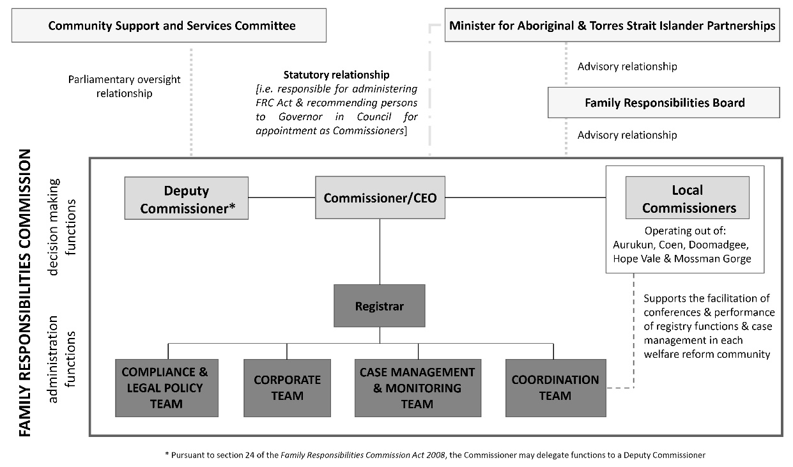

Our vision
Vibrant welfare reform communities that are responsible, healthy, safe and sustainable.

Our values
Our core values provide the framework for our decisions, actions and behaviours, and underpin our commitment to human rights. Working to our values requires us to meet the highest standards of corporate behaviour:
Safety: | The right for everyone to live in safe communities
Respect: | We believe that respect for oneself builds the foundation for wellbeing
Ownership: | We are committed to encouraging communities to take ownership of their present and future
Innovation: | We actively seek and encourage creative ideas to build the potential for lasting change
Empowerment: | We are committed to empowering people to take the initiative to reform their communities and build their own direction and future
Diversity: | We are passionate about respecting the diversity and cultural richness within each community

Strategic objectives
Our strategic objectives for 2018-2023 are to:
- support the restoration of socially responsible standards of behaviour and local authority in welfare reform communities
- help people in welfare reform communities to resume primary responsibility for the wellbeing of their communities and the individuals and families of their communities
- create a capable, agile and innovative organisation
- know our clients, communities and build partnerships.

The Strategic Plan 2018-2023 can be found in the appendices (Appendix A). Our performance against the Strategic Plan 2018-2023 is addressed throughout this report.

In the diagram above the FRC has maintained the title for our Minister as the “Minister for Aboriginal & Torres Strait Islander Partnerships” as this was the title in 2022-23 until May 2023.
Two new Local Commissioners for the Coen community have been appointed from 1 July 2023.
Section 24 of the Family Responsibilities Commission Act 2008.

